BUSINESS REQUIREMENT DOCUMENT (BRD)
CGFMU / MUDRA – Data Collection API & Quarterly Bill Generation Enhancement
Proposed Flow based on Requirement Meeting Discussion and Business IT CR
Document Item | Details
Module | CGFMU / MUDRA – New CG Data Collection API & Billing
Requirement Type | Enhancement / CR
Prepared By | Pinkey
Reviewed By | Rahul/Jatin

Table of Content
1. Introduction 3
2. Scope 3
3. Key Business Requirements 3
A) Current Process — CGFMU Scheme (New CG Module) 3
1. Portfolio Creation 3
2. Input Management 4
3. New CG Data Upload 4
4. File Status Flow 4
5. Validation Output 4
6. Tentative Bill Generation 4
7. Submission for MLI Approval 4
8. NCGTC Approval & Data Flow 4
9. Statement of Estimate (Final Bill) 4
10. Payment Processing 4
11. Tax Invoice Generation 4
Diagram 1 — Current Process Flow (Excel Upload) 5
4. Proposed Changes 8
4.1 UI Enhancement for Access Configuration 8
4.2 Change in Data Submission Format 8
4.3 Enable/Disable option for Data Submission: 8
4.4 New CG Process Flow for API-Based MLIs 8
4.5 Tentative Bill Generation for API-Based MLIs 21
Example Case 21
4.6 Quarterly Statement of Estimates 21
4.6.1 Update File Logic for Base Period Data (Cross-Quarter Tentative & Final Bill Generation) through API/Excel Upload. 21
4.7 Update CG API for Disbursement 23
4.8 User Roles & Responsibility Matrix 27
4.9 Exception handling 28
4.10 Key Business Rules 29
5. API Security 30

1. Introduction
This BRD outlines the changes required in the Surge Application to support Excel upload and JSON-based data submission by MLIs (Member Lending Institutions) to NCGTC in the Credit Guarantee Fund for Micro Units (CGFMU). The purpose of this enhancement is to introduce/extend the CGFMU (MUDRA) Data Collection API-based processing and streamline quarterly bill generation. The proposed solution will allow loan account data to be submitted through the Data Collection API, perform backend validation and CG Fee calculation, generate a File Reference ID, maintain a consolidated tentative bill for the applicable quarter, retain the required MLI approval flow, and support final bill/estimate generation after the applicable quarter-end conditions are fulfilled.
Background
Previously, MLIs could upload data in the Surge system using Excel formats. With the new enhancement, certain MLIs will now be able to send data exclusively through API using JSON format as well. This requires modifications across configuration, data intake, billing and quarterly invoicing processes.

2. Scope
In Scope:
- Develop Admin UI to control Excel upload or API access and disable manual upload for API-enabled MLIs.
- Enable Data Collection API for New CG loan and disbursement data, including Tarun Plus.
- Validate API data, generate tentative bills, and support quarterly invoice automation.
- Perform data validation and identify valid/invalid records, Calculate CG Fee for eligible records, Generate and maintain consolidated tentative bills.

3. Key Business Requirements

A) Current Process — CGFMU Scheme (New CG Module)
This is the process followed today for all MLIs submitting data through the Excel upload on the UI.

1. Portfolio Creation
- The NCGTC Creator creates a new portfolio under the Portfolio Management Module.
- Once the portfolio is created, data will be uploaded against this portfolio.

2. Input Management
- The user navigates to the Input Management page.
- Portfolio Selection: The user selects the portfolio that was created earlier.
- After selecting the portfolio, the system displays the Base Period (Q1, Q2, Q3, or Q4) to which the portfolio belongs.

3. New CG Data Upload
- Under the New CG section, the user uploads the data file in Excel format.
- On clicking Upload, the file gets uploaded and the service begins processing.

4. File Status Flow
- Initial Status: 30007 (Draft)
- After processing, the system updates the file status to: 30015 (Validated)

5. Validation Output
- Once validated, the system identifies:
- Valid Records → stored in table (TempValidation)
- Invalid/Error Records → stored in table (TempValidationError)
- Both valid and invalid record counts/details are visible on the portal.

6. Tentative Bill Generation
- After valid records are finalized, the system automatically generates a Tentative Bill.
- MLI Maker verifies the tentative bill.

7. Submission for MLI Approval
- After validation, the MLI Maker initiates approval by clicking Send to Approval.
- Status changes from: 30015 → 30016 (MLI Approved).
- If rejected by the MLI Checker, status updates to: 30006 (Rejected).

8. NCGTC Approval & Data Flow
- After MLI Approver approves the file, The NCGTC Creator can reviews and approves the file ahead.
- Upon approval, the processed entries are pushed into the LoanApplication table (the main operational table).

9. Statement of Estimate (Final Bill)
- After approval, the MLI Maker can generate the Final Bill (Statement of Estimate).

10. Payment Processing
- The MLI makes the payment via VAN Number.
- The payment details reflect under the Payment Management tab.

11. Tax Invoice Generation
- Once payment is successful, the system generates the Tax Invoice & store in table (CGfeepaymentdetails).

Diagram 1 — Current Process Flow (Excel Upload)
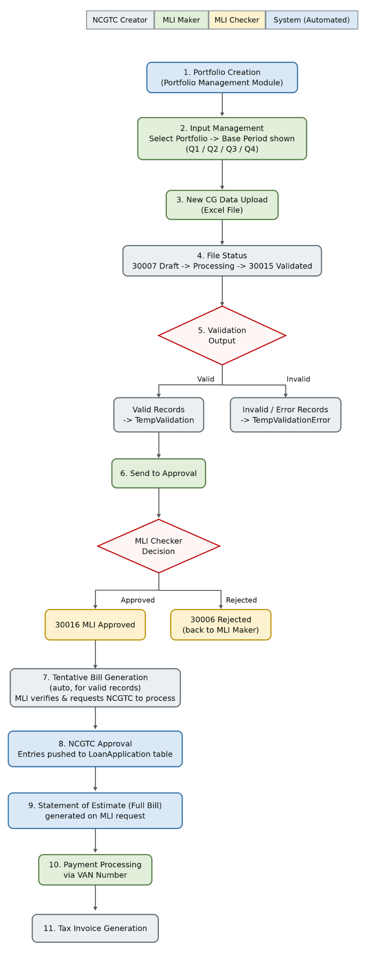

Diagram 1: Current end-to-end flow for Excel based MLIs, coloured by responsible actor.

4. Proposed Changes
Two data-submission channels will co-exist going forward: the existing UI-based Excel upload (unchanged) and a new API-based JSON submission channel. Which channel an MLI uses is controlled centrally by NCGTC Admin.

4.1 UI Enhancement for Access Configuration
To provide access control for how an MLI can submit data (Excel or JSON through API), a new UI module must be developed. Within this UI, the NCGTC Admin should be able to:
- Enable or disable the option for an MLI to submit data through API in JSON format.
- View the following data on screen: MLI Name, Data Submission Mode (API/Excel).
This configuration will directly update the new “Data Submission Mode” field in the MLI Master and will determine which functionalities (Excel upload or API submission) are available to the respective MLI within the system.
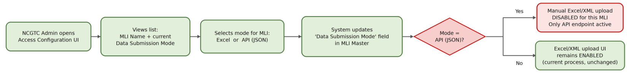
Diagram 2: NCGTC Admin configuration flow that switches an MLI between Excel and API (JSON) mode.

4.2 Change in Data Submission Format
- Earlier, MLIs were allowed to upload data in Excel (as described in Step 3 of Section A).
- As proposed, designated MLIs will also be able to send data to NCGTC through API in JSON format.
- The system must support seamless integration and validation of incoming JSON data.

4.3 Enable/Disable option for Data Submission:
- A new option must be created for NCGTC admin on UI to enable/disable the below mentioned mode:
- Data Submission Mode: Excel upload or API (JSON)
- NCGTC Admin should be able to data submission mode at any time.
- Based on this field, the system must enable/disable the corresponding functionality for that MLI (see Diagram 2).

4.4 New CG Process Flow for API-Based MLIs

- MLI maker enters the New CG Data into the system through an API (JSON) which includes the loan account and disbursement details through the Data Collection API, including Tarun Plus data.
- System receives the data. Once the Validation completes and after that CG Fee Calculation (tentative bill) will run automatically for the Valid records. Once CG fee calculation done then Valid records export into excel & will be displayed at MLI side/NCGTC Side in download format.
- There is no per-submission NCGTC approval step. NCGTC's only approval checkpoint in that case MLI missed the duration (Quarter end) of bill generation.
- MLI and NCGTC can download a running Tentative Report (CG Fee Data) at any time from UI.

Proposed API flow steps:
- New CG File Push via API — the MLI Maker sends New CG data loan-account/disbursement data, including Tarun Plus category to NCGTC as a JSON payload (MLI Maker user).
- Each successful data submission shall generate a unique File Reference ID.
Below is the request New CG Data:
S. No. | Field Name | Description | Type | Mandatory/Optional | Validation
1 | Loan Category | Is the loan under PMMY or PMJDY (overdraft) scheme | List | Mandatory | Refer the Loan Category Code Master in – ‘SURGE - Code Masters’ for the possible values.
2 | Borrowers Name | For PMMY - Unit Borrowers Name who has availed the loan under the PMMY scheme  For PMJDY - Borrowers Name who has availed the loan under the PMJDY scheme | Text – First Name + Middle Name + Last Name (Space Separated) | Mandatory | a-z
 |  |  |  |  | A-Z
 |  |  |  |  | 0-9
 |  |  |  |  | `
 |  |  |  |  | \
 |  |  |  |  | /
 |  |  |  |  | .
 |  |  |  |  | SPACE
 |  |  |  |  | (
 |  |  |  |  | )
 |  |  |  |  | -
 |  |  |  |  | _
 |  |  |  |  | '
 |  |  |  |  | "
 |  |  |  |  | ,
&
(Note '&' character is not a valid character. However, in case it is needed to use this character, then, MLI's are requested to replace '&' with the character string '&amp;' )
 |  |  |  |  | ;
These character set are NOT permitted:
~ {
! }
* [
= ]
| +
? :
> @
< # ^ $
3 | Borrower Type | Type of Borrower | List | Mandatory | Refer the Borrower Type Code Master in – ‘SURGE - Code Masters’ for the possible values.
4 | Units Constitution | Units constitution’s | List | Mandatory | Refer the Unit Constitution Code Master in – ‘SURGE - Code Masters’ for the possible values.
5 | Gender | Borrower’s Gender | List | Mandatory | Refer the Gender Code Master in – ‘SURGE - Code Masters’ for the possible values.
6 | Udyog Adhaar No. | Udyog Adhaar No. of the borrower | Number | Optional | 0-9
 |  |  |  |  | NULL Which means <uadhaar></uadhaar>
7 | Minority community | Is Borrower of Minority community | List | Mandatory | ‘Y’ - If Borrower Belongs to Minority Community
 |  |  |  |  | ‘Y’ - If Borrower Does Not Belongs to Minority Community
8 | Religion | Borrower’s religion. Like Hindu/Muslim/Sikh etc. | List | Mandatory | Refer the Religion Code Master in – ‘SURGE - Code Masters’ for the possible values.
9 | Caste Category | Borrower’s caste category. Like SC/ST/OBC/NT etc. | List | Mandatory | Refer the Caste Category Code Master in – ‘SURGE - Code Masters’ for the possible values.
10 | Borrowers - Present - Address Line | For PMMY - Unit Borrowers Present Address of Residence - Room no. & Building  For PMJDY - Borrowers Present Address of Residence - Room no. & Building | Alphanumeric | Mandatory | a-z
 |  |  |  |  | A-Z
 |  |  |  |  | 0-9
 |  |  |  |  | `
 |  |  |  |  | !
 |  |  |  |  | @
 |  |  |  |  | #
 |  |  |  |  | $
 |  |  |  |  | ^
 |  |  |  |  | *
 |  |  |  |  | (
 |  |  |  |  | )
 |  |  |  |  | -
 |  |  |  |  | _
 |  |  |  |  | +
 |  |  |  |  | =
 |  |  |  |  | {
 |  |  |  |  | }
 |  |  |  |  | [
 |  |  |  |  | ]
 |  |  |  |  | \
 |  |  |  |  | |
 |  |  |  |  | ;
 |  |  |  |  | :
 |  |  |  |  | '
 |  |  |  |  | "
 |  |  |  |  | ,
 |  |  |  |  | .
 |  |  |  |  | ?
 |  |  |  |  | /
 |  |  |  |  | SPACE
These character set are NOT permitted:
~
&
>
<
11 | Borrowers - Present - City/Town/Village | For PMMY - Unit Borrowers/ Present Address of Residence – village  For PMJDY - Borrowers Present Address of Residence – village | Alphanumeric | Mandatory | a-z
 |  |  |  |  | A-Z
 |  |  |  |  | 0-9
 |  |  |  |  | `
 |  |  |  |  | !
 |  |  |  |  | @
 |  |  |  |  | #
 |  |  |  |  | $
 |  |  |  |  | ^
 |  |  |  |  | *
 |  |  |  |  | (
 |  |  |  |  | )
 |  |  |  |  | -
 |  |  |  |  | _
 |  |  |  |  | +
 |  |  |  |  | =
 |  |  |  |  | {
 |  |  |  |  | }
 |  |  |  |  | [
 |  |  |  |  | ]
 |  |  |  |  | \
 |  |  |  |  | |
 |  |  |  |  | ;
 |  |  |  |  | :
 |  |  |  |  | '
 |  |  |  |  | "
 |  |  |  |  | ,
 |  |  |  |  | .
 |  |  |  |  | ?
 |  |  |  |  | /
 |  |  |  |  | SPACE
These character set are NOT permitted:
~
&
>
<
12 | Borrowers - Present - District | For PMMY - Unit Borrowers Present Address of Residence – District  For PMJDY - Borrowers Present Address of Residence – District | List | Mandatory | Refer the District Code Master in – ‘SURGE - Code Masters’ for the possible values.
13 | Borrowers - Present - State | For PMMY - Unit Borrowers Present Address of Residence – State  For PMJDY - Borrowers Present Address of Residence – State | List | Mandatory | Refer the State Code Master in – ‘SURGE - Code Masters’ for the possible values.
14 | Borrowers - Present - Pin Code | For PMMY - Unit Borrowers Present Address of Residence – Pin Code  For PMJDY - Borrowers Present Address of Residence – Pin Code | Number | Mandatory | 0-9
15 | IFSC Code | For PMMY - Banks IFSC code Disbursing the Loan Amount  For PMJDY - Banks IFSC code Disbursing the Overdraft Amount | Alphanumeric | Mandatory | a-z
 |  |  |  |  | A-Z
 |  |  |  |  | 0-9
16 | Customer ID | Unique Customer Id issued by the MLI/Bank for each borrower | Alphanumeric | Mandatory | a-z
 |  |  |  |  | A-Z
 |  |  |  |  | 0-9
17 | Loan Account Number | For PMMY - Loan Account Number allotted by Bank/MLI. A Unique Number as per respective MLI’s procedure.  For PMJDY - Loan Account Number for the overdraft allotted by Bank/MLI. A Unique Number as per respective MLI’s procedure. | Alphanumeric | Mandatory | a-z
 |  |  |  |  | A-Z
 |  |  |  |  | 0-9
18 | Sanctioned Loan Amount/Limit | For PMMY - Loan amount sanctioned by MLI as per scheme eligibility rules/guidance.  For PMJDY – Limit of Overdraft Amount sanctioned by MLI as per scheme eligibility rules/guidance. | Number With 2 Decimals | Mandatory | 0-9
19 | Sanctioned Loan Date | For PMMY - Date of Loan Sanction by MLI as per scheme eligibility rules/guidance.  For PMJDY - Date of Limit (Overdraft) Sanctioned by MLI as per scheme eligibility rules/guidance. | Date | Mandatory | DD-MM-YYYY
20 | Loan Amount – First Disbursement | Loan amount disbursed by MLI as a first disbursement as per scheme eligibility rules/guidance | Number With 2 Decimals | Mandatory | 0-9
21 | Date of First Disbursement | Date of first disbursement done by MLI as per scheme eligibility rules/guidance | Date | Mandatory - if Loan Amount - First Disbursement has value greater than zero, Else, NULL (NULL means <frstdisdt></frstdisdt>) | DD-MM-YYYY
22 | Outstanding Loan Amount | Total outstanding amount at the time of sanction/disbursement | Number With 2 Decimals | Mandatory | 0-9  Negative is Not allowed  Greater than zero
23 | Loan Closed | Is the loan account Closed and Outstanding amount paid | List | Mandatory | ‘Y’ - If Loan is closed
 |  |  |  |  | ‘N’ - If loan is NOT closed. Always 'N' for Loan Account is for PMJDY Scheme
24 | Date of Loan Closure | Date when the loan was paid by borrower | Date | If Loan Account is for PMMY Scheme and Closed then date is Mandatory else NULL (NULL means <loanclosedt></loanclosedt>)  - If Loan Account is for PMJDY Scheme then, NO date it should be always NULL (NULL means <loanclosedt></loanclosedt>) | DD-MM-YYYY
25 | Loan Account NPA | NPA status of the loan account marked by MLI | List | Mandatory | ‘Y’ – if marked as NPA
 |  |  |  |  | ‘N’ - if Loan Account is NOT marked as NPA
26 | Date of NPA | Date of NPA | Date | Mandatory, if Loan Account NPA is ‘Y’, Else, NULL (NULL means <npadt></npadt>) | DD-MM-YYYY
27 | NPA Category | Specify the category of NPA like – Substandard, Doubtful or Loss | List | Mandatory if Loan Account NPA is marked as 'Y' Else, NULL (NULL means <npacat></npacat>) | Refer the NPA Category Code Master in – ‘SURGE - Code Masters’ for the possible values.
28 | Type of Loan | Type of loan availed | List | Mandatory | Refer the Loan Type Code Master in – ‘SURGE - Code Masters’ for the possible values.
29 | Overdue Amount | Overdues Amount if Any. Provide the overdue amount, else zeroes | Number With 2 Decimals | Mandatory | 0-9
30 | Overdue Amount Category | This is the overdue category like – Non Stress Asset, Stress Asset -1 and Stress Asset – 2 | List | Mandatory | Refer the Overdue Category Code Master in – ‘SURGE - Code Masters’ for the possible values.
31 | Pan No. | Pan no. of borrower | Alphanumeric | Optional | a-z
 |  |  |  |  | A-Z
 |  |  |  |  | 0-9
 |  |  |  |  | NULL Which means <pan></pan>
32 | Whether loans availed under Tarun Category earlier? | If “Yes” then only eligible for Tarun Plus loan. | List | Mandatory for Tarun Plus Loans | ‘Y’ - If any loans are availed by borrower earlier under 'Tarun' Category
 |  |  |  |  | ‘N’ - If NO loans are availed by borrower earlier under 'Tarun' Category
33 | Whether previous loan accounts repaid satisfactorily? | If “Yes” then only eligible for Tarun Plus loan. | List | Mandatory for Tarun Plus Loans | ‘Y’ - If all previous loan accounts are repaid satisfactorily.
 |  |  |  |  | ‘N’ - If previous loan accounts are NOT repaid satisfactorily.
34 | Whether any loans of the borrower are NPA/suit filed/ settled/OTS etc. | If “No” then only eligible for Tarun Plus loan. | List | Mandatory for Tarun Plus Loans | ‘Y’ - If any loans of the borrower are NPA/suit filed/ settled/OTS etc.
 |  |  |  |  | ‘N’ - If NO loans of the borrower are NPA/suit filed/ settled/OTS etc.
35 | Mobile Number | Mobile number of Borrowers | Number | Optional | 0-9
 |  |  |  |  | 10 digit number
36 | Aadhaar Number | Aadhaar number of Borrowers (last masked 4 digit) | 4 digit Number | Optional | 0-9
37 | Is loan account number refers to the New to credit borrower. | New to Credit :- A micro unit Borrower for which Guarantee cover is being sought shall be considered as New to Credit when the Borrower has not taken any Business loan earlier from the Banking system for income generating activity. New to credit implies Fresh business loan exposure of the Borrower. | List | Optional | ‘Y’ - If loan account number refers to the New to credit borrower.
 |  |  |  |  | ‘N’ - loan account number Not refers to the New to credit borrower.
38 | Whether collateral security obtained? | i)If the MLI update Collateral security and Third-party guarantee obtained field is “Yes” then system should reject the record.  ii)If the MLI update Collateral security and Third-party guarantee obtained field is “No” system should accept the record for further process. | List | This field will be made mandatory effective from 1st October 2026  Before 1st oct 2026 MLI can proceed by keeping this field as blank | ‘Y’ - If collateral security obtained
 |  |  |  |  | ‘N’ - If collateral security is not obtained
39 | Whether third party guarantee obtained obtained? | i)If the MLI update Collateral security and Third-party guarantee obtained field is “Yes” then system should reject the record.  ii)If the MLI update Collateral security and Third-party guarantee obtained field is “No” system should accept the record for further process. | List | This field will be made mandatory effective from 1st October 2026  Before 1st oct 2026 MLI can proceed by keeping this field as blank | ‘Y’ - If third party guarantee obtained
 |  |  |  |  | ‘N’ - If third party guarantee is not obtained
40 | HomeStay | The loans may be granted for Homestays/Bed & Breakfast establishments as per Ministry of Tourism, GOI guidelines, as an eligible category and will be provided for purchasing Furniture, Fixture and Equipment and also for renovation/expansion of establishments, subject to fulfilment of PMMY scheme guidelines. The Category of loans will be made applicable from FY 2025-26. | List | This field will be made mandatory effective from 1st Jan 2027  Before 1st Jan 2027 MLI can proceed by keeping this field as blank | ‘Y’
 |  |  |  |  | ‘N’

The API shall provide a response containing the following:
{
"FileRefId : 2808",
"Status": "Success",
"Message": ""
}
Failure Response containing: If the request cannot be processed, the API shall return Appropriate Error Message.

Example 1 – Mandatory Field Validation Failure:
{
"statusCode": 300,
"status": "error",
"message": "All fields are mandatory."
}
Example 2 – Internal Server Error:
{
"statusCode": 500,
"status": "error",
"message": "Internal Server Error"
}
Example 3 – Unauthorized Access Error:
{
"statusCode": 401,
"status": "failure",
"message": "Unauthorized access"
}

- System Validation and CG Fee Calculation — Once the system validates each record individually coming through API will be considered as approved/processed data and after that system will calculates the CG fee Calculation for valid records in the same automated step.
- Valid records move to TempValidation.
- Invalid records move to TempValidationError with the applicable error/rejection reason.
- MLI corrects the invalid records and resubmits them, wherever applicable.
- Tentative Bill Download & Pending Validation Check — A Single tentative bill will be maintained at each quarter (portfolio wise) and available for on-demand download by the MLI or NCGTC at any time, it reflects all approved, valid records received so far in the quarter.
- The MLI may update additional data (new or updated records through update file) any number of times during the quarter, each update re-runs validations and updates the Tentative Report (CG Fee calculation).
- The system checks whether any submitted file/record is still pending processing. If pending records are found, the system displays an alert to the MLI to complete the pending processing in excel upload.
- The system should not allow final bill generation until all applicable pending files/records are processed. This will be applicable only when data received from excel. Data which is received from API will process automatically.
- Final Bill Generation — Once there are no pending files/records and all uploaded files validations are completed and processed, the MLI can proceed with Final Bill Generation, the system compiles the Final Bill (Statement of Estimate) from all approved/processed tentative records for that quarter. Final Bill timing across Base Periods for API-based (JSON)/ excel uploads, including cross-quarter updates, follows the Update Logic defined in Section 4.6.1.below.
At this point no backend process with run to recalculate. The system shall only consider the sum of all files/valid records received and display the calculated amount as the Estimated Invoice.
- NCGTC Side Approval — NCGTC's only approval checkpoint in that case MLI missed the duration (Quarter end) of bill generation.
- Payment Processing — the MLI pays via VAN Number, same as the current process.
- Tax Invoice Generation — the system generates the Tax Invoice.

Diagram 3: Proposed process flow for API (JSON) based MLIs

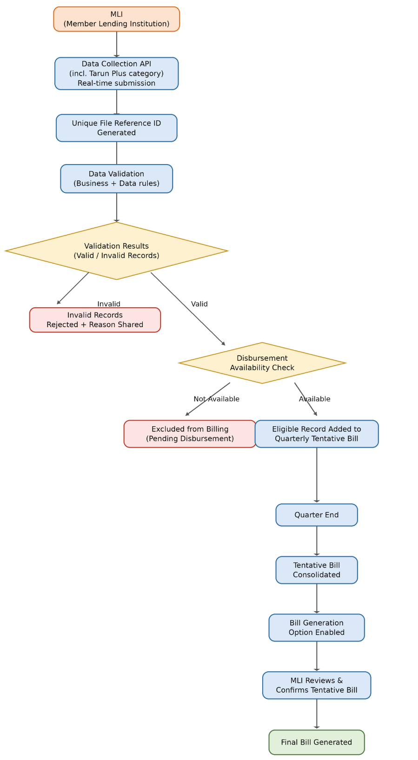

4.5 Tentative Bill Generation for API-Based MLIs
When an MLI Maker submits data through API:
- The system must validate each record individually.
- The data received through the API is also used to generate a tentative bill (CG fee Calculation), similar to the current process followed when data is uploaded through Excel.
- For every API submission, a tentative bill must be generated only for valid records.

Example Case
- First Submission: Total Records: 10 | Valid: 7 | Invalid: 3 → Tentative bill generated for 7 valid records.
- Second Submission: Total Records: 12 (including corrected earlier invalid ones) | System validates all 19 records→ Tentative bill (CG fee calculation) again generated for only the valid records.
- This process continues for every API push.

4.6 Quarterly Statement of Estimates
- At the end of each quarter, the MLI can generate a Statement of Estimates, using a button on the MLI screen — this does not depend on NCGTC action.
- The estimates includes all records for which tentative bills have been generated in that quarter.
- MLIs are allowed to upload or update data for previous quarters multiple times — this is required when an account was sanctioned in a previous quarter but disbursed in the current quarter.
- The system must accept such updates and generate the estimated invoice accordingly.
- The existing invoice generation process must be updated to support the new API-based flow.

4.6.1 Update File Logic for Base Period Data (Cross-Quarter Tentative & Final Bill Generation) through API/Excel Upload.
The system shall allow MLI to upload New CG data for the current quarter as well as the immediately preceding quarter through the API/excel upload, subject to applicable business rules mentioned below.
Business Rule:
- MLI Data uploaded for the current quarter (April to June) shall be accepted in current quarter (check bases on Sanction Date) and considered for tentative bill generation of the same quarter. The tentative bill (CG Fee calculation) shall be calculated and stored in the database.
- The final bill for the current-quarter data shall not be generated in the same quarter (April to June). The final bill shall be generated in the next quarter (July to Sep) as per the applicable billing process.
- In the next quarter (July to Sep), the MLI shall be allowed to upload/update records belonging to the previous uploaded quarter (April to June) records, along with the current-quarter records. If any record from the previous quarter has been updated, such as an account becoming closed, the system shall process the updated record and recalculate the applicable CG Fee as per the approved business rules.
- For the previous-quarter data, the system shall consider the updated eligible records for final bill generation, while the current-quarter data shall continue to be considered for tentative bill generation.
- The same logic shall be applicable across Q1, Q2, Q3 and Q4, i.e., current-quarter data shall contribute to the current quarter's tentative bill and shall become eligible for final bill generation in the next quarter.

Illustration:
Example 1:
- MLI uploads 10 New CG records through the API/Excel upload in Q1 (April to June).
- All 10 records are successfully validated and found eligible.
- The system calculates CG Fee for all 10 records and adds them to the Q1 Tentative Bill.
- The Q1 Final Bill is not generated during Q1, will be generated in next Quarter (July to Sep).
Example 2:
- Out of the 10 Q1 (April to June) records, 2 accounts become Closed.
- MLI uploads the updated Q1 data containing the updated status/details of these records again in Q2 (July to Sep).
- MLI may also upload new records in Q2 (July to Sep) through the same API/Excel.
- The system shall process the Q1 updated records and recalculate the applicable billing details.
- The Q1 Final Bill shall be generated based on the applicable updated/eligible Q1 8 records in Q2 (July to Sep).
- The Q2 records shall continue to be accumulated in the Q2 Tentative Bill and shall not be included in the Q1 Final Bill.
The same approach shall be followed for subsequent quarters. For example, during Q3, the MLI may upload/update Q2 records along with Q3 records, Q2 records shall be considered for Q2 Final Bill generation, while Q3 records shall be considered for Q3 Tentative Bill generation.
Validation Rules:
- Current Quarter Upload (Base Period): The system shall allow MLI to upload records belonging to the current quarter (Check basis the Sanction date) through the API as well as in Excel upload.
- Previous Quarter Update: The system shall allow MLI to upload/update records belonging to the previous quarter along with the current-quarter records.
- Tentative-only for current quarter — For records whose Base Period = current quarter, the system must generate/refresh only the Tentative Bill on every push, Final Bill generation must remain disabled for that Base Period until the quarter rolls over.
- Previous Quarter Final Bill: Eligible records belonging to the immediately preceding quarter shall be considered for final bill generation after processing the applicable updates.
- Final Bill trigger for prior quarter — Final Bill generation for a Base Period becomes available only when: (a) the system has moved into the next quarter, and (b) there are no pending/invalidated records for that Base Period (reusing the existing pending-check rule from Section 4.4).
- Record-count consistency — When previously uploaded records are updated (e.g., marked "Loan Closed"), the Final Bill for that Base Period must reflect the updated record set/count, not the original tentative count.
- Billing Status Validation: Records for which the final bill has already been generated shall be handled as per the applicable post-billing update rules and shall not be treated as fresh records for tentative bill generation.

4.7 Update CG API for Disbursement
The MLI will have the provision to update disbursement details through the Update CG API in cases where the disbursement information was not provided or was missed during the initial New CG data submission.
Below is the request Update CG Data:
S. No. | Field Name | Description | Type | Mandatory/Optional | Validation
1 | Customer ID | Unique Customer Id issued by the MLI/Bank for each borrower | Alphanumeric | Mandatory | a-z
 |  |  |  |  | A-Z
 |  |  |  |  | 0-9
2 | Loan Account Number | For PMMY - Loan Account Number allotted by Bank/MLI. A Unique Number as per respective MLI’s procedure.  For PMJDY - Loan Account Number for the overdraft allotted by Bank/MLI. A Unique Number as per respective MLI’s procedure. | Alphanumeric | Mandatory | a-z
 |  |  |  |  | A-Z
 |  |  |  |  | 0-9
3 | Outstanding Loan Amount | Applicable at the time of renewal. Outstanding loan amount as on 1st April of the FY to be inputted. | Number With 2 Decimals | Mandatory | 0-9  Negative is Not allowed  Greater than zero.  For closed cases the Outstanding Loan Amount should be equal to Zero  For renewal of portfolio outstanding loan amount should be inputted as on April 01 of the Financial Year
4 | Loan Closed | Is the loan account Closed and Outstanding amount paid | List | Mandatory | ‘Y’ - If Loan is closed
 |  |  |  |  | ‘N’ - If loan is NOT closed. Always 'N' for Loan Account is for PMJDY Scheme
5 | Date of Loan Closure | Date when the loan was paid by borrower | Date | If Loan Account is for PMMY Scheme and Closed then date is Mandatory else NULL (NULL means <loanclosedt></loanclosedt>)  - If Loan Account is for PMJDY Scheme then, NO date it should be always NULL (NULL means <loanclosedt></loanclosedt>) | DD-MM-YYYY
6 | Loan Amount – First Disbursement | Loan amount disbursed by MLI as a first disbursement as per scheme eligibility rules/guidance | Number With 2 Decimals | Mandatory | 0-9
7 | Date of First Disbursement | Date of first disbursement done by MLI as per scheme eligibility rules/guidance | Date | Mandatory - if Loan Amount - First Disbursement has value greater than zero, Else, NULL (NULL means <frstdisdt></frstdisdt>) | DD-MM-YYYY
8 | Loan Account NPA | NPA status of the loan account marked by MLI | List | Mandatory | ‘Y’ – if marked as NPA
 |  |  |  |  | ‘N’ - if Loan Account is NOT marked as NPA
9 | Date of NPA | Date of NPA | Date | Mandatory, if Loan Account NPA is ‘Y’, Else, NULL (NULL means <npadt></npadt>) | DD-MM-YYYY
10 | NPA Category | Specify the category of NPA like – Substandard, Doubtful or Loss | List | Mandatory if Loan Account NPA is marked as 'Y' Else, NULL (NULL means <npacat></npacat>) | Refer the NPA Category Code Master in – ‘SURGE - Code Masters’ for the possible values.
11 | Overdue Amount | Overdues Amount if Any. | Number With 2 Decimals | Mandatory | 0-9
12 | Overdue Amount Category | This is the overdue category like – Non Stress Asset, Stress Asset -1 and Stress Asset – 2 | List | Mandatory | Refer the Overdue Category Code Master in – ‘SURGE - Code Masters’ for the possible values.
13 | Modified Sanctioned Loan Amount/Limit | For PMMY - Enhanced/Reduced Sanctioned Loan amount by MLI as per scheme eligibility rules/guidance.  For PMJDY – Enhanced/Reduced limit of Overdraft Amount sanctioned by MLI as per scheme eligibility rules/guidance. | Number With 2 Decimals | Mandatory | 0-9  If loan amount not enhanced/reduced keep the same as previous amount  If loan amount is enhanced/reduced update the modified amount.
14 | Date of Modified Sanctioned Loan Amount/Limit | For PMMY - Date when the Sanctioned Loan Amount is Enhanced/Reduced by MLI as per scheme eligibility rules/guidance.  For PMJDY - Date when the Sanctioned Limit of Overdraft Amount is Enhanced/Reduced by MLI as per scheme eligibility rules/guidance | Date | Mandatory if 'Modified Sanctioned Loan Amount/Limit' is greater than Zeroes, else NULL (NULL means <modsancdt></modsancdt>) | DD-MM-YYYY  If loan amount not enhanced/reduced keep the loan sanctioned date as same as previous date  If loan amount is enhanced/reduced update the modified sanctioned date.
15 | Pan No. | Pan no. of borrower | Alphanumeric | Optional | a-z
 |  |  |  |  | A-Z
 |  |  |  |  | 0-9
 |  |  |  |  | NULL Which means <pan></pan>
16 | Whether loans availed under Tarun Category earlier? | If “Yes” then only eligible for Tarun Plus loan. | List | Mandatory for Tarun Plus Loans | ‘Y’ - If any loans are availed by borrower earlier under 'Tarun' Category
 |  |  |  |  | ‘N’ - If NO loans are availed by borrower earlier under 'Tarun' Category
17 | Whether previous loan accounts repaid satisfactorily? | If “Yes” then only eligible for Tarun Plus loan. | List | Mandatory for Tarun Plus Loans | ‘Y’ - If all previous loan accounts are repaid satisfactorily.
 |  |  |  |  | ‘N’ - If previous loan accounts are NOT repaid satisfactorily.
18 | Whether any loans of the borrower are NPA/suit filed/ settled/OTS etc. | If “No” then only eligible for Tarun Plus loan. | List | Mandatory for Tarun Plus Loans | ‘Y’ - If any loans of the borrower are NPA/suit filed/ settled/OTS etc.
 |  |  |  |  | ‘N’ - If NO loans of the borrower are NPA/suit filed/ settled/OTS etc.
19 | modifiedloancat | MLI has to add loan catagory | List | Mandatory | If not upgrading keep same as Previous loan category
 |  |  |  |  | If upgrading loan catagory add upgraded loan catagory
20 | HomeStay | The loans may be granted for Homestays/Bed & Breakfast establishments as per Ministry of Tourism, GOI guidelines, as an eligible category and will be provided for purchasing Furniture, Fixture and Equipment and also for renovation/expansion of establishments, subject to fulfilment of PMMY scheme guidelines. The Category of loans will be made applicable from FY 2025-26. | List | This field will be made mandatory effective from 1st Jan 2027  Before 1st Jan 2027 MLI can proceed by keeping this field as blank | ‘Y’
 |  |  |  |  | ‘N’

The API shall provide a response containing the following:
{
"FileRefId : 2808",
"Status": "Success",
"Message": ""
}
Failure Response containing: If the request cannot be processed, the API shall return Appropriate Error Message.

Validations Rules:
- MLI Maker submits the missing/updated disbursement details (Loan Amount – First Disbursement, Date of First Disbursement, and related fields) for an existing loan account through the Update CG API (JSON).
- The system validates the submitted disbursement details against the existing loan account and the applicable field-level/business validations.
- On successful validation, the eligible loan account is updated with the disbursement details.
- The account becomes eligible for billing based on the applicable business rules (an account with no/zero disbursement value is not billable until disbursement is confirmed).
- The corresponding CG Fee/billing details are calculated and updated for the account.
- The Tentative/Final Bill (as applicable for the current Base Period, per Section 4.6.1) is generated or updated for the respective loan account.

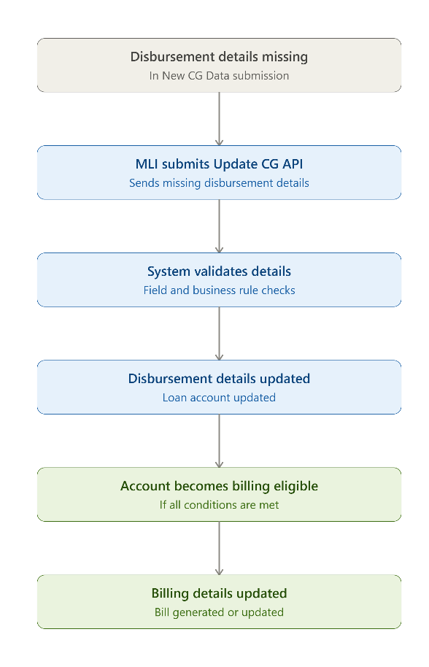

4.8 User Roles & Responsibility Matrix
The table below maps each role to its responsibility across both submission channels, for a quick client-facing view of who does what.
Role | Excel Flow (Current) | API (JSON) Flow (Proposed)
NCGTC Admin | Not involved in day-to-day flow. | Configures Data Submission Mode (Excel vs. API) per MLI in the MLI Master.
NCGTC Creator | Creates the portfolio.  Approves each validated file before it is pushed to LoanApplication.  Generates the Final Bill on MLI request. | Creates the portfolio.  No per-submission approval.  Generate only the quarter-end Final Bill.  Views the pending-bills dashboard across MLIs.
MLI Maker (System User for API) | Selects portfolio, uploads Excel file.  Sends validated data for approval.  Requests NCGTC to process the tentative bill.  Makes payment via VAN. | Pushes CG data via API (JSON), any number of times per quarter.  Sends validated data for approval.  Downloads the Tentative Report on demand.  Makes payment via VAN.
MLI Checker / Approver | Approves or rejects the file sent by the MLI Maker (30016 / 30006). | Approves or rejects each validated batch sent by the MLI Maker — same control, unchanged.
System (Automated) | Runs Excel validation.  Splits records into TempValidation / TempValidationError.  Auto-generates the tentative bill.  Generates the Tax Invoice. | Validates each JSON record and calculates the CG fee in the same step.  Maintains the live Tentative Report.  Compiles the quarter-end Final Bill.  Generates the Tax Invoice.

4.9 Exception handling

Exception Type | Description
Invalid Data | Invalid records shall be rejected and the applicable validation reason shall be provided to the MLI.
Missing Disbursement | If the required disbursement information is not available, the respective loan account shall not be included in bill generation.
Duplicate Submission | Duplicate records or duplicate transactions shall be identified and processed according to the approved duplicate-handling business rules.
Closed Account After Billing | If an account is marked as Closed after a bill has already been generated, the system shall update the applicable billing details, including CG Fee and taxes, in accordance with the approved business rules.
API Failure | In case of API failure, the system shall return an appropriate error response and ensure that the failed transaction does not result in duplicate data or duplicate billing.

4.10 Key Business Rules

Rule ID | Business Rule
BR-01 | MLI shall submit Tarun Plus and applicable loan account data through the Data Collection API.
BR-02 | Each successful data submission shall generate a unique File Reference ID.
BR-03 | The MLI shall have separate portfolios for the current quarter and previous quarter.
BR-04 | Data uploaded in the current-quarter portfolio shall not be eligible for final bill generation until the quarter ends.
BR-05 | Data for the applicable previous quarter shall be available for completion and billing activities.
BR-06 | A single tentative bill shall be maintained for each quarter.
BR-07 | The tentative bill shall consolidate all eligible and validated records uploaded for the respective quarter.
BR-08 | Only valid records shall be considered for billing.
BR-09 | Records without required disbursement details shall not be included in bill generation.
BR-10 | The Bill Generation option shall be enabled only after the applicable quarter ends.
BR-11 | The MLI shall review/confirm the tentative bill before final bill generation, where applicable.
BR-12 | An account becoming Closed during the quarter shall be updated through the prescribed Update File mechanism.
BR-13 | If a bill has already been generated, applicable CG Fee and taxes shall be recalculated/updated based on the approved business rules.
BR-14 | Missing disbursement details may be updated through the Update CG API.
BR-15 | Upon successful disbursement update, the account shall be considered for billing as per applicable business rules.
BR-16 | All data submissions, updates, validations and billing transactions shall be auditable.

5. API Security
The API developed for the CGFMU Scheme shall implement the required security controls to ensure secure data transmission, encryption, authentication, and integrity of API.
The following security parameters shall be implemented:-
Parameters | Required
AES | AES
AES-256 | 256 bits / 32 bytes
Mode | GCM
Padding | No Padding
IV | First 12 bytes of AES key
GCM tag | 16 bytes
Dynamic 32-character key | Required
RSA encryption of AES key | Required
RSA 2048 X509 | Required
OAEP | Required
SHA-256 signature | Required
RSA digital signature | Required

Suggestions to be discussed with Business/IT Team
1. Multiple MLI Maker File Upload Scenario:
Suppose an MLI has multiple MLI Makers. If one MLI Maker uploads a file and at the same time, another MLI Maker from the same MLI uploads a second file, the system currently overwrites the first uploaded file with the second file to reduce CG fee multiple variation.

Second approach – Second check at the time upon MLI maker upload to check whether the portfolio file is in validated state or not.
2. Upon Multiple MLI Maker Uploads:
If multiple MLI Makers upload loan records for the same MLI, the system will retain only the latest uploaded loan records along with the applicable CG Fee calculation. The previously uploaded records, including their calculated CG Fee details, will be removed from the relevant table before processing the latest upload.

